**CA3 report b10505057**

Problem2

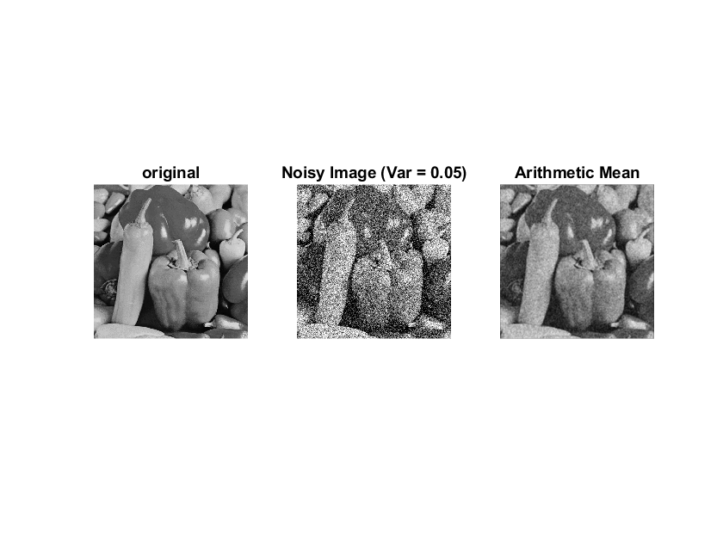

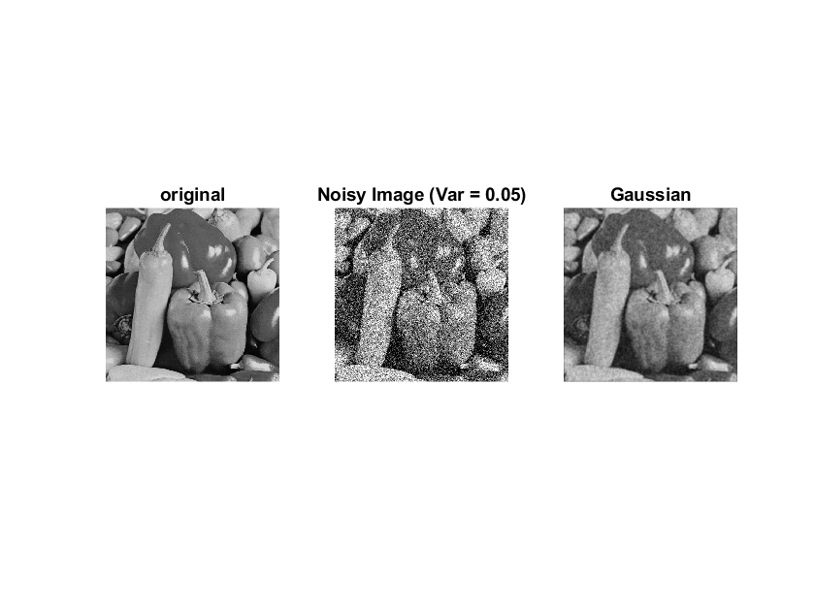

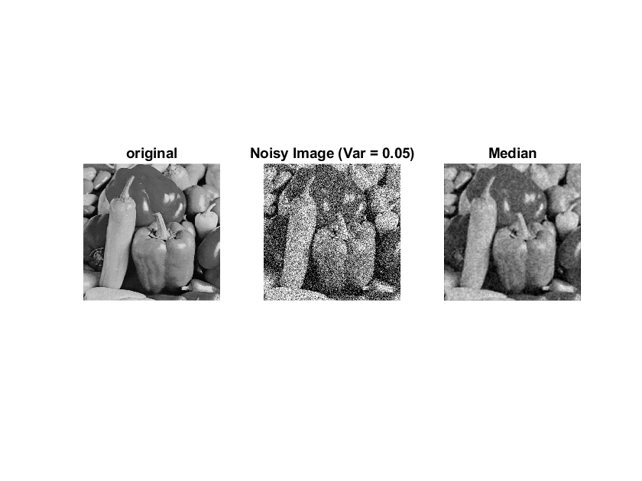

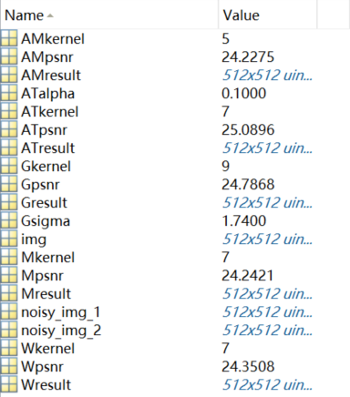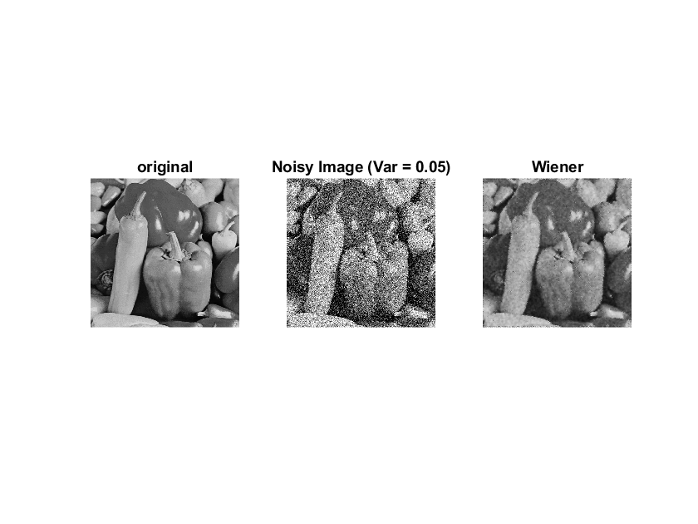

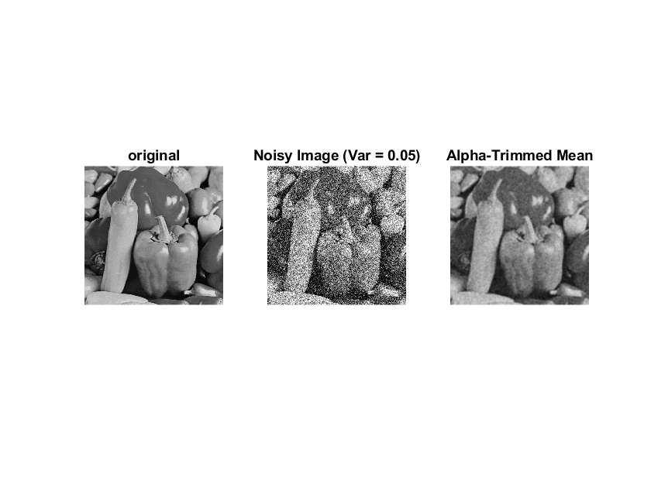

|  |  |  |  |  |  |
| --- | --- | --- | --- | --- | --- |
| Var=0.05 | Arithmetic mean | Gaussian | Median | Wiener | Alpha-trimmed |
| best kernel | 5 | 9 | 7 | 7 | 7 |
| Best PSNR | 24.23 | 24.79 | 24.24 | 24.35 | 25.09 |
| best param |  |  |  |  |  |

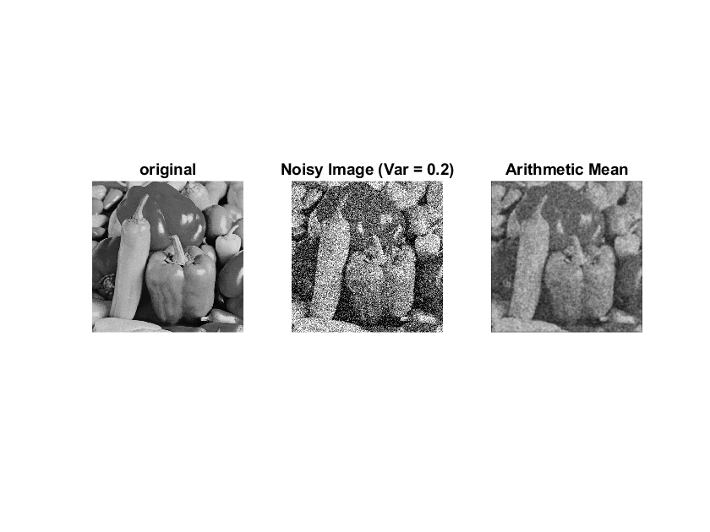

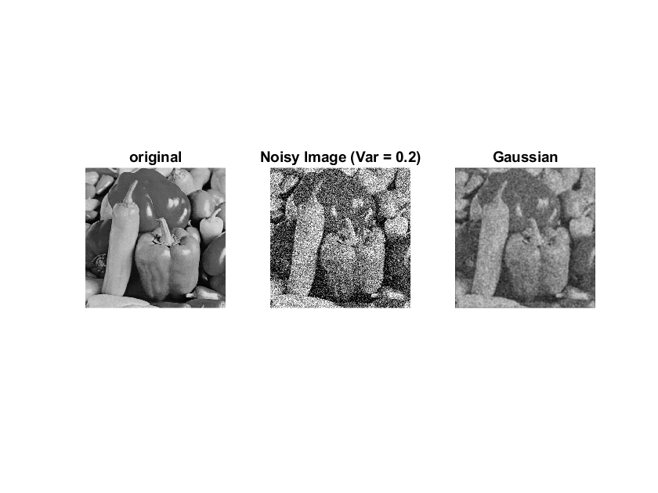

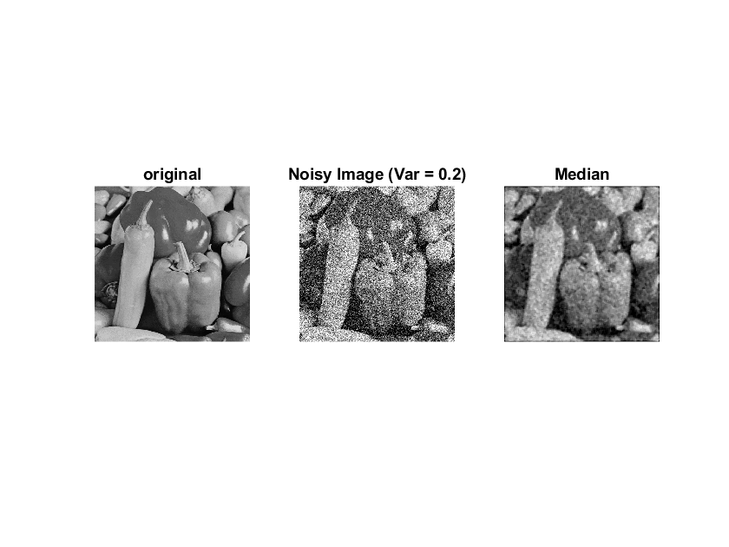

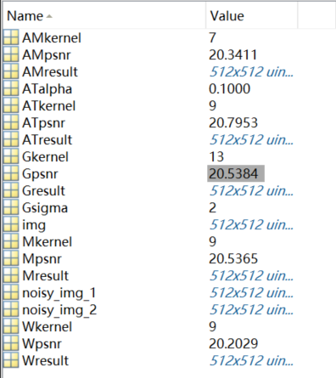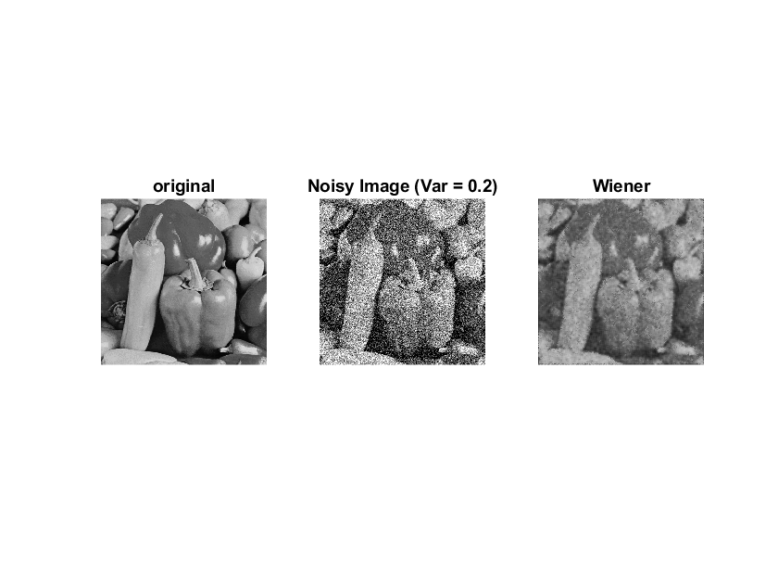

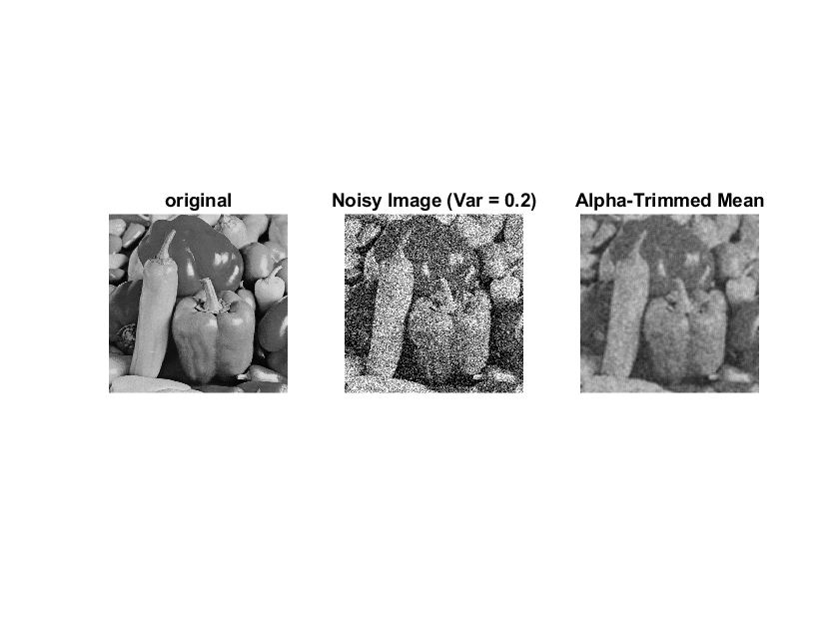

|  |  |  |  |  |  |
| --- | --- | --- | --- | --- | --- |
| Var=0.05 | Arithmetic mean | Gaussian | Median | Wiener | Alpha-trimmed |
| best kernel | 7 | 13 | 9 | 9 | 9 |
| Best PSNR | 20.34 | 20.54 | 20.54 | 20.20 | 20.80 |
| best param |  |  |  |  |  |

Problem3

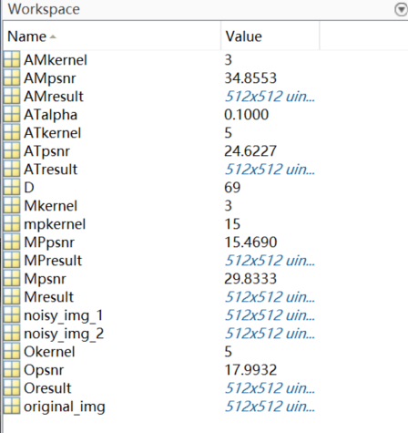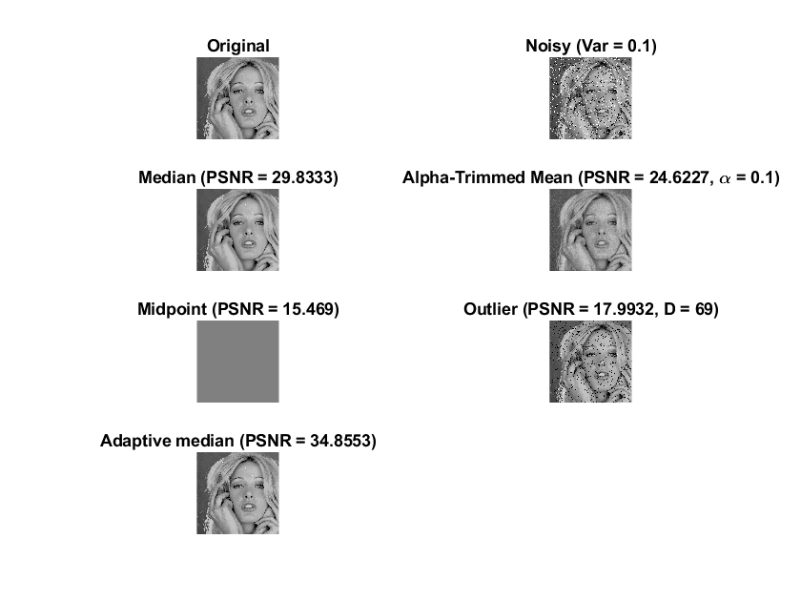

|  |  |  |  |  |  |
| --- | --- | --- | --- | --- | --- |
| Noise density=0.1 | Median | Alpha-trimmed | Midpoint | Outlier | Adaptive median |
| best kernel | 3 | 5 | 15 | 5 | 3(max size) |
| Best PSNR | 29.83 | 24.62 | 15.47 | 17.99 | 34.86 |
| best param |  |  |  |  |  |

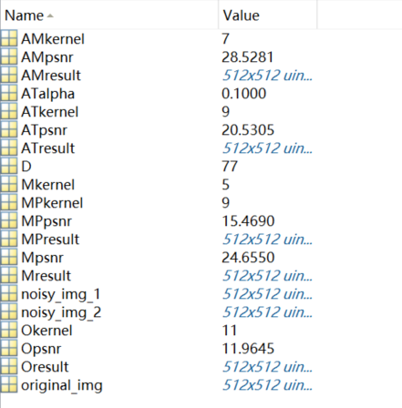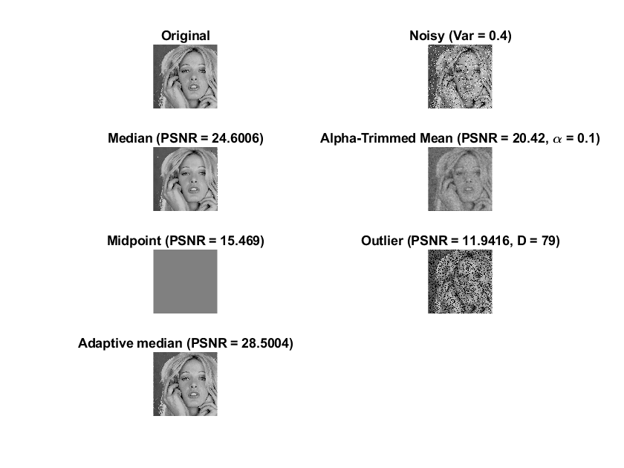

|  |  |  |  |  |  |
| --- | --- | --- | --- | --- | --- |
| Noise density=0.4 | Median | Alpha-trimmed | Midpoint | Outlier | Adaptive median |
| best kernel | 5 | 9 | 5 | 11 | 7(max size) |
| Best PSNR | 24.60 | 20.42 | 15.47 | 11.94 | 28.50 |
| best param |  |  |  |  |  |

Problem4

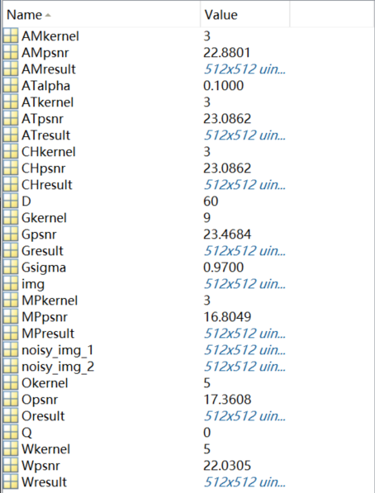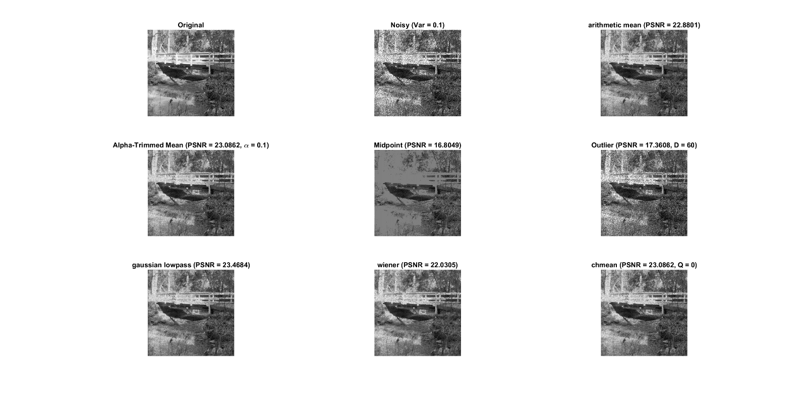

|  |  |  |  |  |  |  |  |
| --- | --- | --- | --- | --- | --- | --- | --- |
| Var=0.1 | Arithmetic mean | Gaussian | Wiener | Outlier | Alpha-trimmed | Midpoint | Contraharmonic |
| best kernel | 3 | 9 | 5 | 5 | 3 | 5 | 3 |
| Best PSNR | 22.88 | 23.47 | 22.03 | 17.36 | 23.07 | 16.80 | 23.09 |
| best param |  |  |  |  |  |  |  |

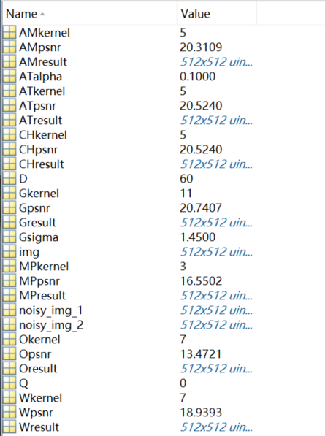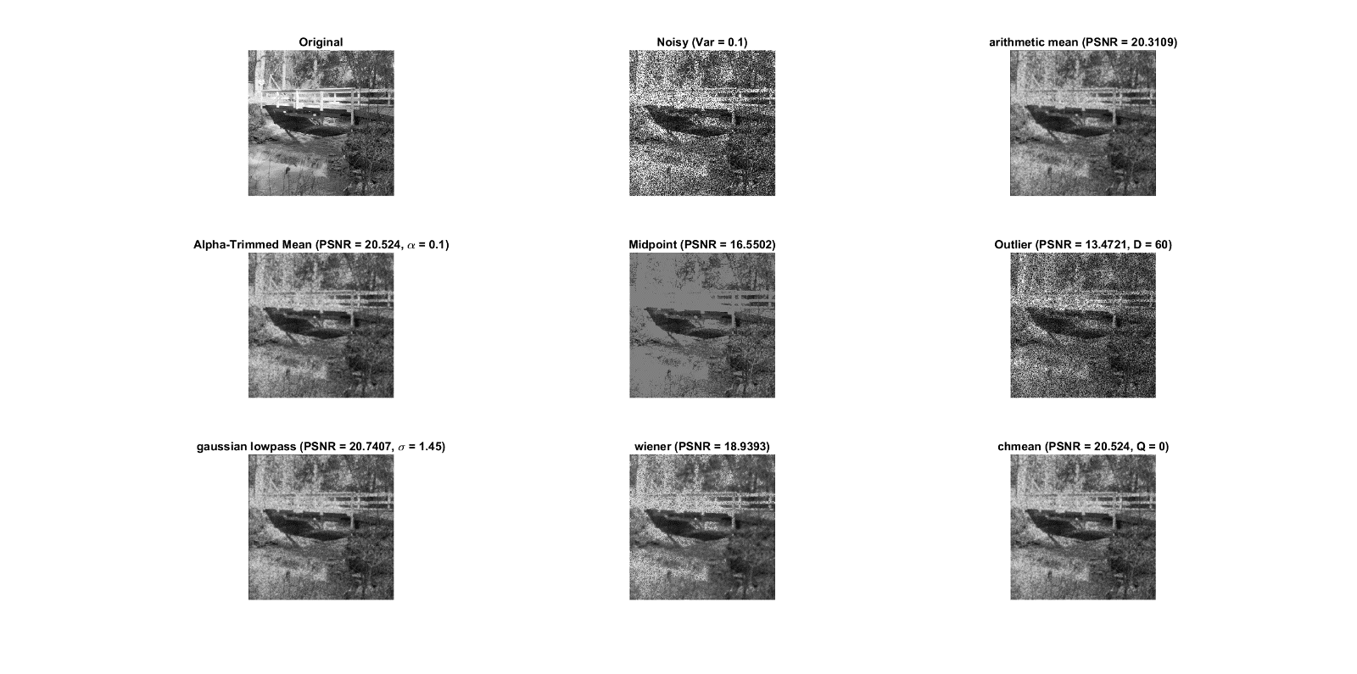

|  |  |  |  |  |  |  |  |
| --- | --- | --- | --- | --- | --- | --- | --- |
| Var=0.3 | Arithmetic mean | Gaussian | Wiener | Outlier | Alpha-trimmed | Midpoint | Contraharmonic |
| best kernel | 5 | 11 | 7 | 7 | 5 | 3 | 5 |
| Best PSNR | 20.31 | 20.74 | 18.94 | 13.47 | 20.52 | 16.55 | 20.52 |
| best param |  |  |  |  |  |  |  |

**Discuss:**

Kernel size的範圍是3~15每次增加2，的範圍是0.1~2每次遞增0.1，的範圍是0.1~0.5每次遞增0.1，D的範圍是60~80每次遞增1，Q的範圍是-3~3每次遞增1。

Problem2：可發現不論var=0.05或0.2時，這五個濾波器的PSNR值都差不多，且從肉眼看起來也並無明顯差別。

Problem3：肉眼可見outlier的效果特別差，尤其是在雜訊上升後outliner psnr又下降了不少。而adaptive median的效果特別好，可見其PSNR值較其他濾波器高出不少，且其還原的圖從肉眼來看跟原圖幾乎相差無幾。剩下的濾波器表現也都不錯，PSNR都差不多，但效果都沒有adaptive median好。

Problem4：與第三題一樣outliner表現特別差，且D值都停留在60(邊界值)，故我推測表現不佳的原因可能是因為D值範圍需要再做調整。而其他的濾波器表現都差不多，PSNR值也相差不多。

特別要注意的是midpoint的結果在第三題出來不知為何是灰色的，我有特別寫一個*test.m*去檢查是否為函式問題，不過就結果而言這個midpoint function應該是沒問題的(如下圖，padding為replicate的形式)。而在第四題測試的結果出來是有顯示出圖片的，故我推測第三題的灰色圖片可能與原圖的影像強度分布過於集中造成濾波效果不佳。

